EXPERIMENT NO# 01

OBJECTIVE:
To understand the basic structure and functioning of a blockchain and implement a simple blockchain with multiple blocks using Python.

EQUIPMENT

Computer with Python 3.x installed, Google Colab or Jupyter notebook for code execution and Internet connection to install required packages (if any).

THEORY

Blockchain is a decentralized ledger which consists of blocks chained together via cryptographic hashes. Each block contains data, a timestamp, a nonce (for mining), and the hash of the previous block. Mining involves calculating a hash with a certain difficulty target (proof-of-work), ensuring tamper-resistance and security.

Mathematically, for block i:

$${hash}_{i}=SHA-256(index\left\|timestamp\left\|data\left\|nonce\left\|previous_hash\right.\right.\right.\right.)$$

where $\left\|denotes concatenation.\right.$

EXPERIMENT AND PROGRAMMING

OBSERVATION-01

Open the Google Colab

Open the File

Upload the Jupyter File from below link

https://github.com/niaz1971/Digital_Transformation_Industry_4_5/blob/main/PRACTICAL_WORK_BOOK/CREATE_BLOCK_CHAIN.ipynb
import hashlib
import datetime
import networkx as nx
import matplotlib.pyplot as plt

class Block:
def __init__(self, index, timestamp, data, previous_hash):
self.index = index
self.timestamp = timestamp
self.data = data
self.previous_hash = previous_hash
self.nonce = 0
self.hash = self.calculate_hash()

def calculate_hash(self):
content = str(self.index) + str(self.timestamp) + str(self.data) + str(self.previous_hash) + str(self.nonce)
return hashlib.sha256(content.encode()).hexdigest()

def mine_block(self, difficulty):
prefix = '0' * difficulty
while self.hash[:difficulty] != prefix:
self.nonce += 1
self.hash = self.calculate_hash()

class Blockchain:
def __init__(self):
self.chain = [self.create_genesis_block()]
self.difficulty = 4

def create_genesis_block(self):
return Block(0, datetime.datetime.now(), "Genesis Block", "0")

def get_latest_block(self):
return self.chain[-1]

def add_block(self, new_block):
new_block.previous_hash = self.get_latest_block().hash
new_block.mine_block(self.difficulty)
self.chain.append(new_block)

def is_chain_valid(self):
for i in range(1, len(self.chain)):
curr = self.chain[i]
prev = self.chain[i-1]

if curr.hash != curr.calculate_hash():
return False
if curr.previous_hash != prev.hash:
return False
return True

def plot_blockchain(blockchain):
G = nx.DiGraph()

for block in blockchain.chain:
label = f"Index:{block.index}\nHash:{block.hash[:6]}...\nNonce:{block.nonce}"
G.add_node(block.index, label=label)

for i in range(1, len(blockchain.chain)):
G.add_edge(blockchain.chain[i-1].index, blockchain.chain[i].index)

pos = nx.spring_layout(G, seed=42) # layout for neat visualization
labels = nx.get_node_attributes(G, 'label')
plt.figure(figsize=(12,6))
nx.draw(G, pos, with_labels=True, labels=labels, node_size=2500, node_color='lightblue', font_size=8, font_weight='bold', arrows=True)
plt.title("Blockchain Structure Visualization")
plt.show()

# Main execution

my_blockchain = Blockchain()

for i in range(1, 11):
print(f"Mining block {i}...")
data = {"amount": i * 10}
new_block = Block(i, datetime.datetime.now(), data, "")
my_blockchain.add_block(new_block)

# Print blockchain details
for block in my_blockchain.chain:
print(f"Index: {block.index}")
print(f"Timestamp: {block.timestamp}")
print(f"Data: {block.data}")
print(f"Hash: {block.hash}")
print(f"Previous Hash: {block.previous_hash}\n")

print("Is blockchain valid?", my_blockchain.is_chain_valid())

# Plot the blockchain structure
plot_blockchain(my_blockchain)

Run the Code

RESULT

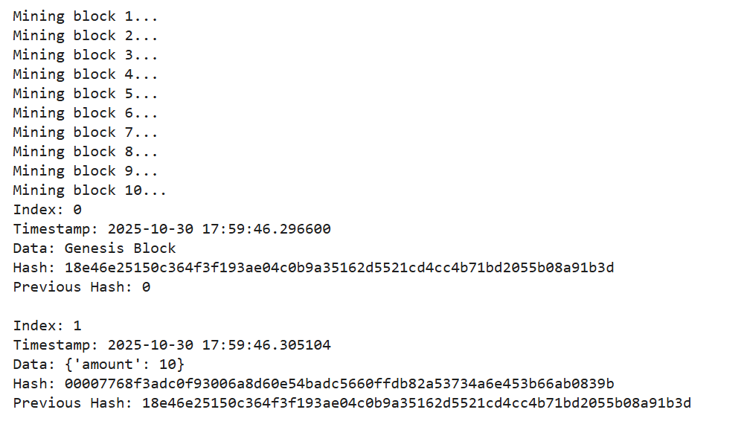

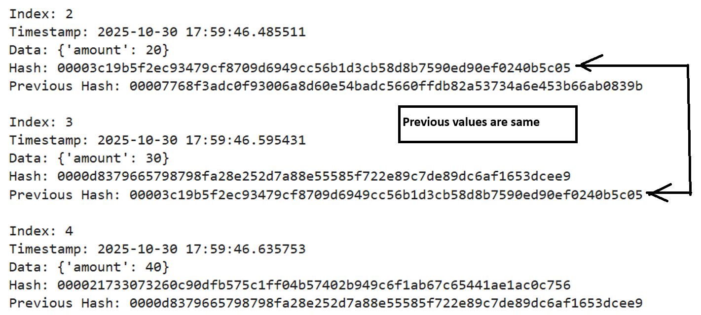

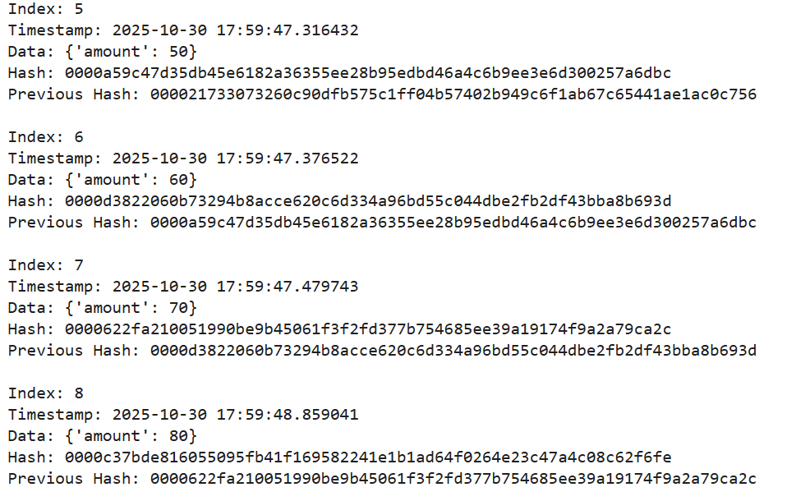

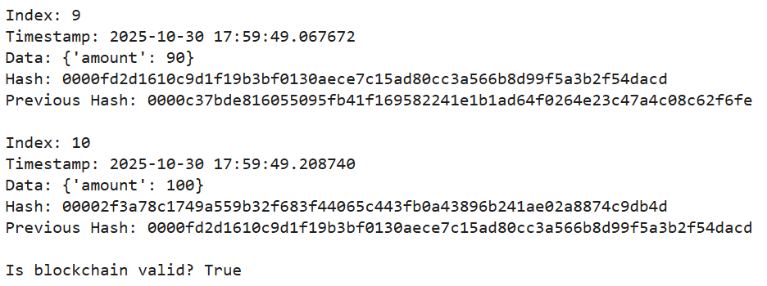

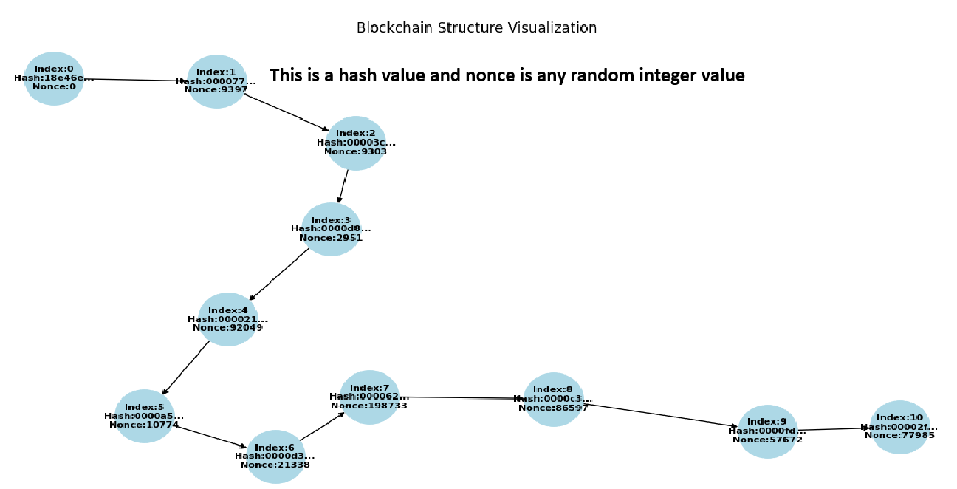

OBSERVATION-02

Open the Google Colab

Open the File

Upload the Jupyter File from below link

https://github.com/niaz1971/Digital_Transformation_Industry_4_5/blob/main/PRACTICAL_WORK_BOOK/CREATE_BLOCK_CHAIN_KHUZDAR_HOSPITAL.ipynb

Run the Code

import hashlib
import datetime
import networkx as nx
import matplotlib.pyplot as plt

class Block:
def __init__(self, index, timestamp, data, previous_hash):
self.index = index
self.timestamp = timestamp
self.data = data
self.previous_hash = previous_hash
self.nonce = 0
self.hash = self.calculate_hash()

def calculate_hash(self):
content = str(self.index) + str(self.timestamp) + str(self.data) + str(self.previous_hash) + str(self.nonce)
return hashlib.sha256(content.encode()).hexdigest()

def mine_block(self, difficulty):
prefix = '0' * difficulty
while self.hash[:difficulty] != prefix:
self.nonce += 1
self.hash = self.calculate_hash()

class Blockchain:
def __init__(self):
self.chain = [self.create_genesis_block()]
self.difficulty = 4

def create_genesis_block(self):
return Block(0, datetime.datetime.now(), "Genesis Block", "0")

def get_latest_block(self):
return self.chain[-1]

def add_block(self, new_block):
new_block.previous_hash = self.get_latest_block().hash
new_block.mine_block(self.difficulty)
self.chain.append(new_block)

def is_chain_valid(self):
for i in range(1, len(self.chain)):
curr = self.chain[i]
prev = self.chain[i-1]
if curr.hash != curr.calculate_hash() or curr.previous_hash != prev.hash:
return False
return True

def plot_blockchain(blockchain):
G = nx.DiGraph()
for block in blockchain.chain:
label = f"Index: {block.index}\nHash: {block.hash[:6]}...\nNonce: {block.nonce}"
G.add_node(block.index, label=label)
for i in range(1, len(blockchain.chain)):
G.add_edge(blockchain.chain[i-1].index, blockchain.chain[i].index)
pos = nx.spring_layout(G, seed=42)
labels = nx.get_node_attributes(G, 'label')
plt.figure(figsize=(10,5))
nx.draw(G, pos, with_labels=True, labels=labels, node_color='lightcyan', node_size=2000, font_size=8, arrows=True)
plt.title("Blockchain of Patient Records - Jhalawan Hospital Khuzdar")
plt.show()

# Patient data for 3 blocks - Jhalawan Hospital Khuzdar
patient_data = [
{"hospital": "Jhalawan Hospital Khuzdar", "patient_name": "Ali", "diagnosis": "Flu"},
{"hospital": "Jhalawan Hospital Khuzdar", "patient_name": "Muhammad", "diagnosis": "Cold"},
{"hospital": "Jhalawan Hospital Khuzdar", "patient_name": "Ahmed", "diagnosis": "Diabetes"}
]

# Initialize blockchain and add blocks
blockchain = Blockchain()
for i, pdata in enumerate(patient_data, 1):
print(f"Mining block {i} for patient {pdata['patient_name']}...")
new_block = Block(i, datetime.datetime.now(), pdata, "")
blockchain.add_block(new_block)

# Display blockchain details
for block in blockchain.chain:
print(f"Index: {block.index} | Data: {block.data} | Hash: {block.hash}")

print("\nIs blockchain valid?", blockchain.is_chain_valid())

# Plot blockchain
plot_blockchain(blockchain)

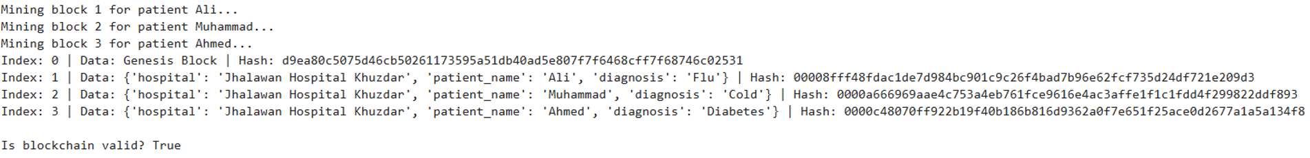

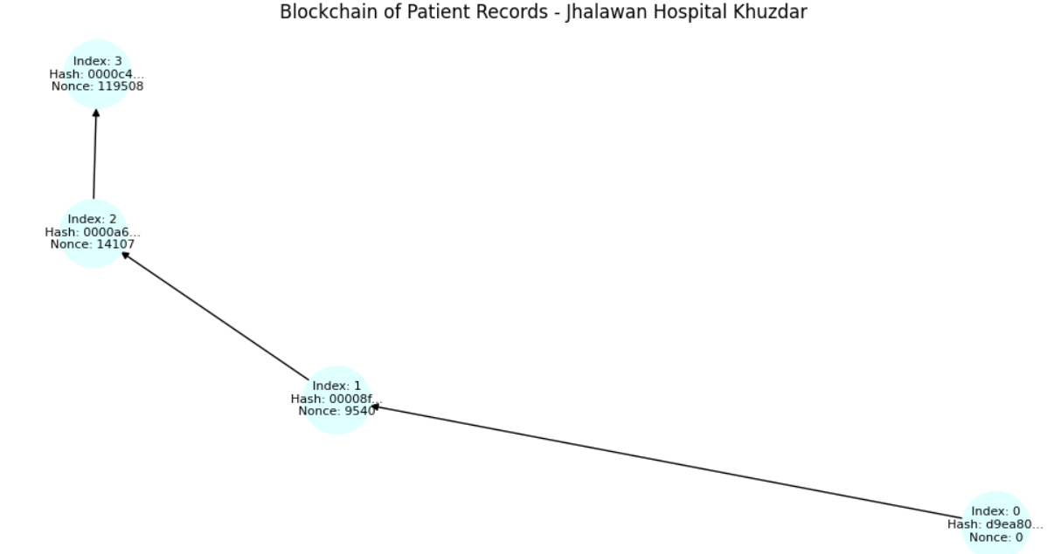

EXERCISE

Write a Python and sets up a blockchain for five patients of any hospital near to your city, write five patients names, create the mining blocks, indexes, also verify is it blockchain valid? And finally draw blockchain structure.

